Name : HARSHRAJSINH ZALA Reg no : 22BCE2238

Q1:

Code:

<!DOCTYPE html>

<html lang="en">

<head>

<meta charset="UTF-8">

<meta name="viewport" content="width=device-width, initial-scale=1.0">

<title>FORM</title>

</head>

<body>

<h1>Welcome to Forms</h1>

<div id="header"></div>

<form action="#">

<label for="academicyear">Academic Year: </label>

<select name="Academic Year" id="acadyear">

<option value="2022">2022</option>

<option value="2023">2023</option>

<option value="2024">2024</option>

</select><br>

<label for="semester">Semester: </label>

<select name="semester" id="semester">

<option value="fallsem">Fall Sem</option>

<option value="wintersem" selected>Winter Sem</option>

</select><br>

<label for="degree">Degree: </label>

<select name="degree" id="degree">

<option value="Btech" selected>Btech</option>

<option value="Mtech">Mtech</option>

</select><br>

<label for="capstone">Capstone project done at: </label>

<select name="capstone" id="capstone">

<option value="Btech">Btech</option>

<option value="Mtech">Mtech</option>

</select><br>

<label for="description">Project Title: </label>

<textarea name="t1" id="t1" cols="30" rows="1">Project Title</textarea><br>

<label for="studnum">No of students in branch: </label>

<input type="number" min="0" placeholder="0"><br>

<label for="description">Registration number of students<br><div class="reducesize" style="font-size: small;">(Registration number of the students one below the another)</div></label>

<textarea name="t1" id="t1" cols="30" rows="10">List nos of students one below the another</textarea><br>

<label for="industryname">Name of Industry: </label>

<input type="text" name="industryname" id="industryname" placeholder="Name of the industry"><br>

<label for="country">Country </label>

<select name="country" id="country">

<option value="India" selected>India</option>

<option value="USA">USA</option>

<option value="UK">UK</option>

</select><br>

<hr>

<input type="submit" value="submit">

<input type="reset" value="reset"><br>

</form>

</body>

</html>

OUTPUT:

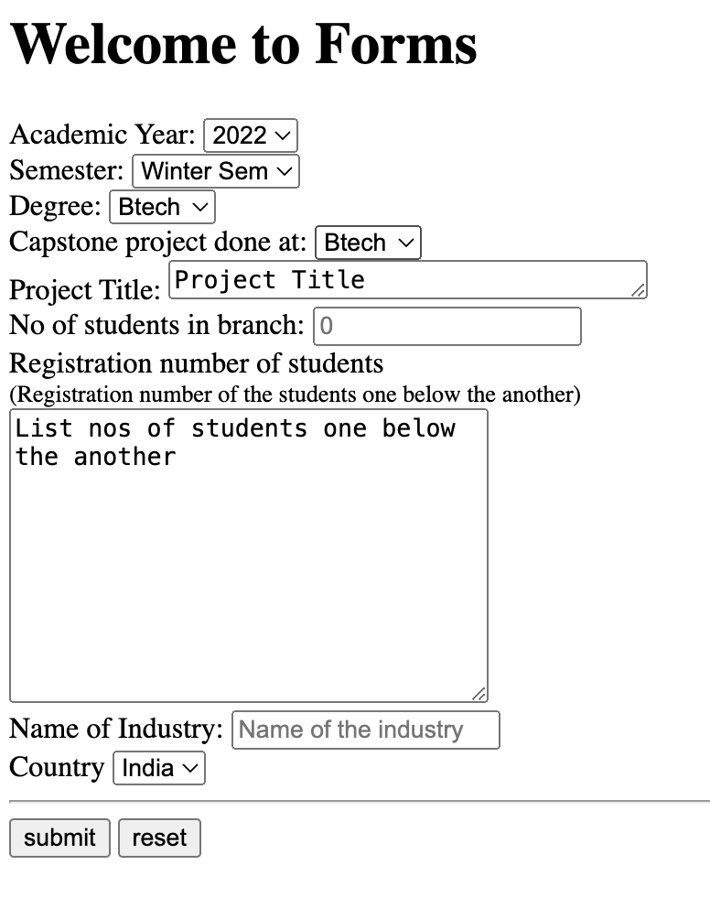

Q2 :

CODE:

<!DOCTYPE html>

<html lang="en">

<head>

<meta charset="UTF-8">

<meta name="viewport" content="width=device-width, initial-scale=1.0">

<title>Form 2</title>

</head>

<body>

<h1>Welcome to Form 2</h1>

<form action="#">

<label for="financialyear">Financial Year: </label>

<select name="financialyear" id="financialyear">

<option value="2022">2022</option>

<option value="2023">2023</option>

<option value="2024">2024</option>

</select><br>

<label for="orgid">Organiser ERP ID: </label>

<input type="number" placeholder="Organiser ERP ID:" required><br>

<label for="coorgid1">Co-Organiser ERP ID 1: </label>

<input type="number" placeholder="Co-Organiser ERP ID 1:" required><br>

<label for="coorgid2">Co-Organiser ERP ID 2: </label>

<input type="number" placeholder="Co-Organiser ERP ID 2:" required><br>

<label for="title">Title of Corporate Training Program: </label>

<textarea name="t1" id="t1" cols="30" rows="1">Title of Corporate Training Program</textarea><br>

<label for="industryname">Name of Industry seeking training: </label>

<input type="text" name="industryname" id="industryname" placeholder="Name of the industry seeking training"><br>

<label for="cityname">City of Agency: </label>

<input type="text" name="cityname" id="cityname" placeholder="City of Agency"><br>

<label for="country">Country of Agency:</label>

<select name="country" id="country">

<option value="India" selected>India</option>

<option value="USA">USA</option>

<option value="UK">UK</option>

</select><br>

<label for="startdate">Start Date</label>

<input type="date" id="date"><br>

<label for="startdate">End Date</label>

<input type="date" id="date" ><br>

<label for="revenue">Revenue generated in rupees </label>

<input type="number" placeholder="Revenue in Rupees" required><br>

<label for="nooftrainees">No of Trainees: </label>

<input type="number" placeholder="0" min="0"><br>

<hr>

<input type="submit" value="submit">

<input type="reset" value="reset"><br>

</form>

</body>

</html> OUTPUT:

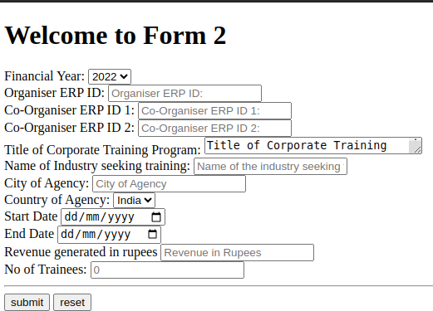

Q3 :

CODE:

<!DOCTYPE html>

<html lang="en">

<head>

<meta charset="UTF-8">

<meta name="viewport" content="width=device-width, initial-scale=1.0">

<title>Form 3</title>

</head>

<body>

<h1>Voter ID Registration System</h1>

<form action="#">

<label for="name">Name: </label>

<input type="text" name="name" id="name" placeholder="Name: "><br>

<label for="address">Address: </label>

<input type="text" name="address" id="address" placeholder="Address"><br>

<label for="phonenumber">Phone Number: </label>

<input type="number" placeholder="+91 xxxxxxxxxx" minlength="10" required><br>

<label for="aadharnumber">Aadhar Number: </label>

<input type="number" placeholder="xxxx xxxx xxxx" minlength="12" required><br>

<label for="birthdate">Birth Date: </label>

<input type="date" id="birthdate" max="2004-12-31"><br>

<label for="country">Country:</label>

<select name="country" id="country">

<option value="India" selected>India</option>

<option value="USA">USA</option>

<option value="UK">UK</option>

</select><br>

<hr>

<input type="submit" value="submit">

<input type="reset" value="reset"><br>

</form>

</body>

</html>

Output:

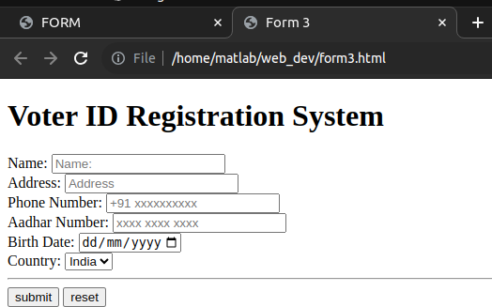

Q4:

Code:

<!DOCTYPE html>

<html lang="en">

<head>

<meta charset="UTF-8">

<meta name="viewport" content="width=device-width, initial-scale=1.0">

<title>Form 4</title>

</head>

<body>

<h1>Welcome to my website</h1>

<video src="videos/funny.mp4" id="video" controls autoplay muted loop height="300" width="300">Video</video>

</body>

</html> OUTPUT :

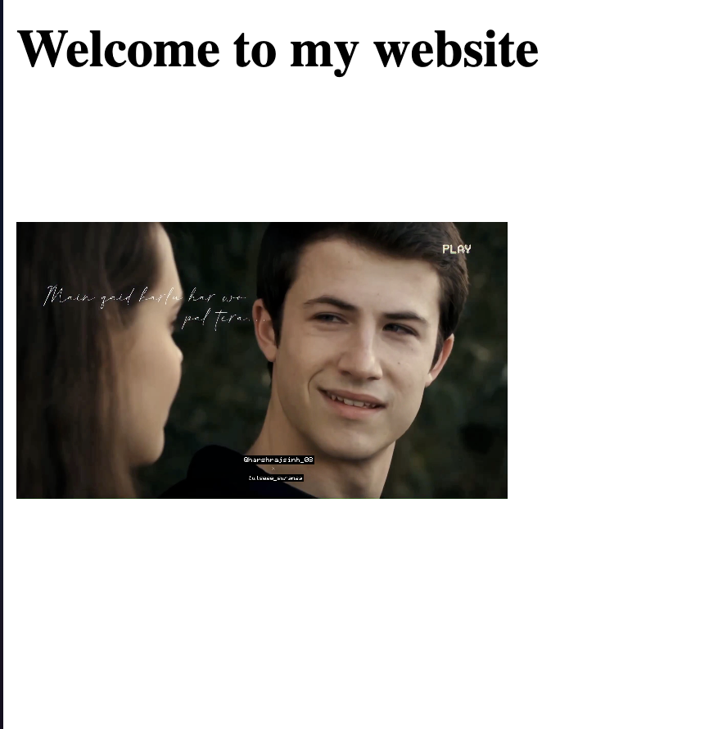

Q5 : HOTEL REGISTRATION FORM CODE :

<!DOCTYPE html>

<html lang="en">

<head>

<meta charset="UTF-8">

<meta name="viewport" content="width=device-width, initial-scale=1.0">

<title>Form 3</title>

</head>

<body>

<h1>Hotel Registration Form</h1>

<form action="#">

<label for="name">Name: </label>

<input type="text" name="name" id="name" placeholder="Name: "><br>

<label for="address">Address: </label>

<input type="text" name="address" id="address" placeholder="Address"><br>

<label for="phonenumber">Phone Number: </label>

<input type="number" placeholder="+91 xxxxxxxxxx" minlength="10" required><br>

<label for="aadharnumber">Aadhar Number: </label>

<input type="number" placeholder="xxxx xxxx xxxx" minlength="12" required><br>

<label for="birthdate">Birth Date: </label>

<input type="date" id="birthdate"><br>

<label for="country">Country:</label>

<select name="country" id="country">

<option value="India" selected>India</option>

<option value="USA">USA</option>

<option value="UK">UK</option>

</select><br>

<label for="Room numbers">Enter number of rooms: </label>

<input type="number" name="numofrooms" id="numofrooms" min="1" placeholder="Number of rooms"><br>

<label for="bookingdates">Room Booking Dates</label>

<input type="date" id="date" min="2024-01-10" max="2024-01-31"><br>

<hr>

<input type="submit" value="submit">

<input type="reset" value="reset"><br>

</form>

</body>

</html>

OUTPUT :

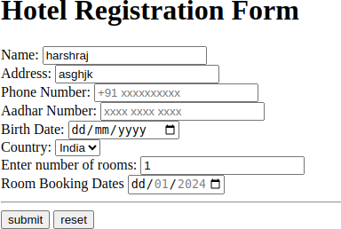

Q 7:

Code:

<!DOCTYPE html>

<html lang="en">

<head>

<meta charset="UTF-8">

<meta name="viewport" content="width=device-width, initial-scale=1.0">

<title>Form7</title>

</head>

<body>

<h1>Hello welcome to my program</h1>

<a href="https://www.codespindle.com"><img src="images/blue.png" alt="blue button"></a>

</body>

</html>

Output :



Q6 : TABLE

Code:

<!DOCTYPE html>

<html lang="en">

<head>

<meta charset="UTF-8">

<meta name="viewport" content="width=device-width, initial-scale=1.0">

<title>Table</title>

</head>

<body>

<h1>Course Details</h1>

<label for="sem">Select Semester: </label>

<select name="sem" id="sem">

<option value="sem1">Winter-Sem 2024</option>

<option value="sem2">Fall-Sem 2023</option>

</select><br>

<br>

<table border="1">

<thead style="background-color:skyblue;">

<tr><th colspan="10">Regular Courses</th></tr>

<tr>

<th>Serial No.</th>

<th>Course Code</th>

<th>Title</th>

<th>Type</th>

<th>Slot</th>

<th>Class Number</th>

</tr>

</thead>

<tbody>

<tr>

<td>1</td>

<td>CSE3002</td>

<td>Internet and Web Programming</td>

<td>ETH</td>

<td>A1</td>

<td>VL20223509867</td>

</tr>

<tr>

<td>2</td>

<td>CSE3002</td>

<td>Internet and Web Programming</td>

<td>ETH</td>

<td>A2</td>

<td>VL20223508768</td>

</tr>

<tr>

<td>3</td>

<td>CSE3002</td>

<td>Internet and Web Programming</td>

<td>ELA</td>

<td>L9+L10</td>

<td>VL20223509345</td>

</tr>

<tr>

<td>4</td>

<td>CSE3002</td>

<td>Internet and Web Programming</td>

<td>ELA</td>

<td>L52+L53</td>

<td>VL20223507689</td>

</tr>

<tr>

<td>5</td>

<td>CSE3002</td>

<td>Internet and Web Programming</td>

<td>ELA</td>

<td>L14+L15</td>

<td>VL20223509665</td>

</tr>

</tbody>

</table>

</body>

</html>

Output:

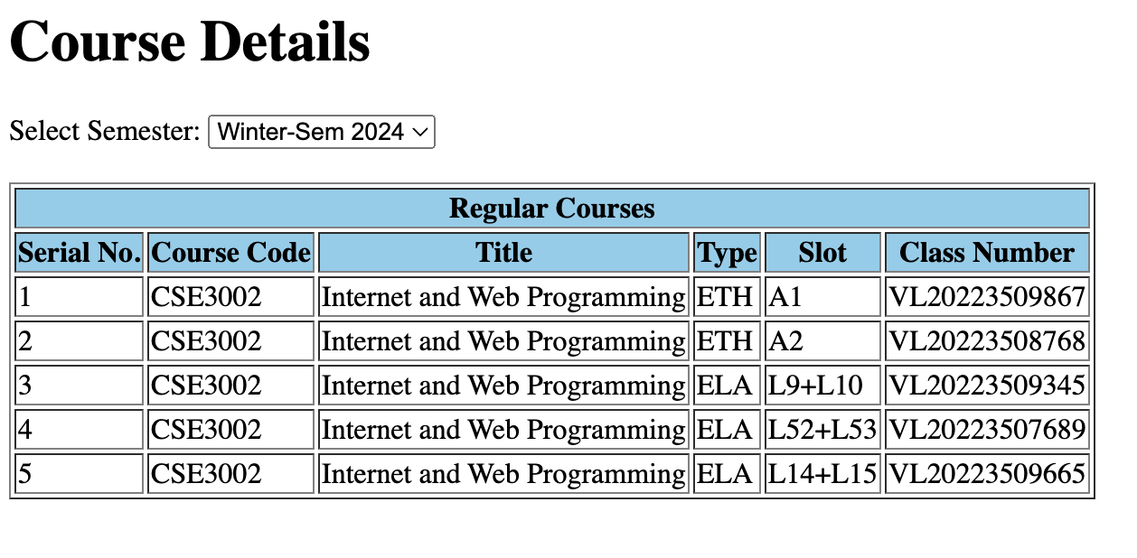

Q7 : button

Code:

<!DOCTYPE html>

<html lang="en">

<head>

<meta charset="UTF-8">

<meta name="viewport" content="width=device-width, initial-scale=1.0">

<title>Form7</title>

</head>

<body>

<h1>Hello welcome to my program</h1>

<a href="https://www.codespindle.com"><img src="images/blue.png" alt="blue button"></a>

</body>

</html>

Output:

Q8 :

Code:

<!DOCTYPE html>

<html lang="en">

<head>

<meta charset="UTF-8">

<meta name="viewport" content="width=device-width, initial-scale=1.0">

<title>Q8</title>

</head>

<body>

<h1>Number 1</h1>

<iframe src="q6.html" title="hello" frameborder="1" height="400" width="400"></iframe>

<h1>Number 2</h1>

<iframe src="q7.html" frameborder="0" height="400" width="400"></iframe>

<h1>Number 3</h1>

<iframe src="form1.html" frameborder="0" height="400" width="400"></iframe>

</body>

</html>

Output:

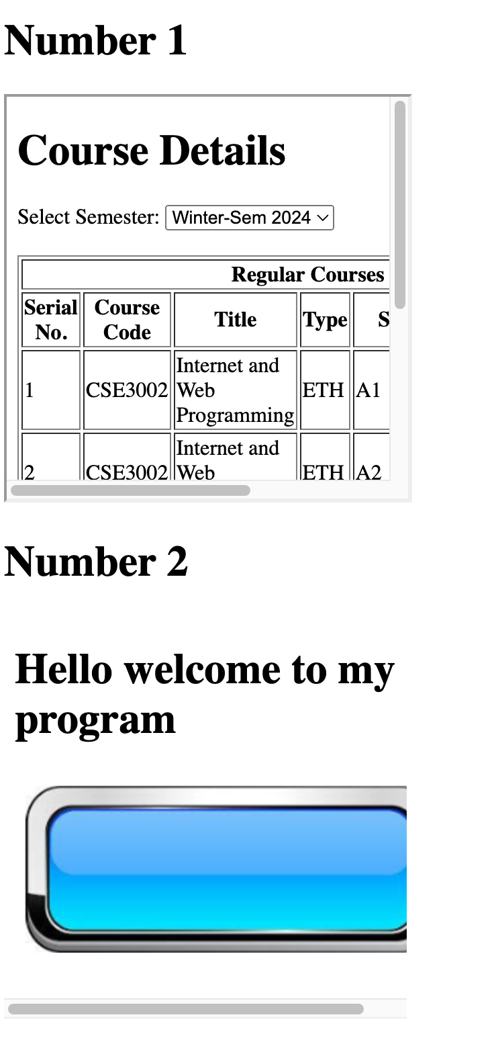

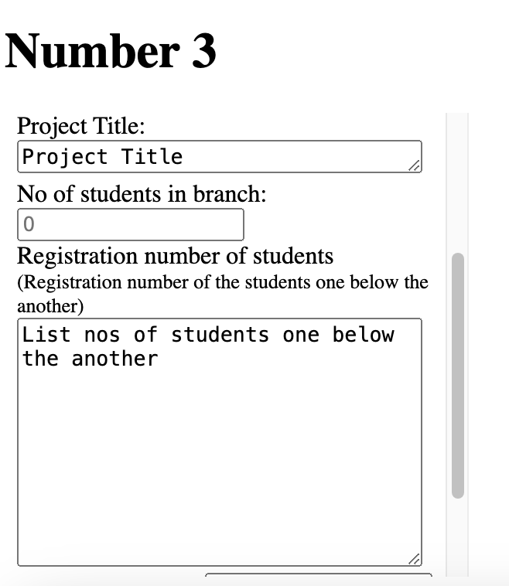

Q9 :

Code:

<!DOCTYPE html>

<html lang="en">

<head>

<meta charset="UTF-8">

<meta name="viewport" content="width=device-width, initial-scale=1.0">

<title>Form 9</title>

</head>

<body>

<h1>Welcome to my Form 9</h1>

<label for="email">Email ID:</label>

<input type="email" name="email" id="email" placeholder="email"><br>

<label for="title">Title/Salutation</label>

<select name="title" id="title">

<option value="shri">Shri</option>

<option value="shrimati">Shrimati</option>

</select><br>

<label for="firstname">First Name: </label>

<input type="text" name="firstname" id="firstname" placeholder="firstname" required>

<br>

<label for="lastname">Last Name: </label>

<input type="text" name="lastname" id="lastname" placeholder="lastname" required>

<br>

<label for="jobtitle">Job Title/Designation: </label>

<input type="text" name="jobtitle" id="jobtitle" placeholder="jobtitle" required>

<br>

<label for="department">Department: </label>

<input type="text" name="department" id="department" placeholder="department" required>

<br>

<label for="institution">Institution: </label>

<input type="text" name="institution" id="institution" placeholder="institution" required>

<br>

<label for="city">City: </label>

<input type="text" name="city" id="city" placeholder="City" required>

<br>

<label for="country">Country</label>

<select name="country" id="country" required>

<option value="India">India</option>

<option value="Pakistan" selected>Pakistan</option>

</select><br>

<label for="phonenum">Phone Number: </label>

<input type="number" name="phonenum" id="phonenum" placeholder="Phone number">

<br>

<hr>

<input type="submit" name="submit" id="submit">

<input type="reset" name="reset" id="reset">

</body>

</html>

OUTPUT :   
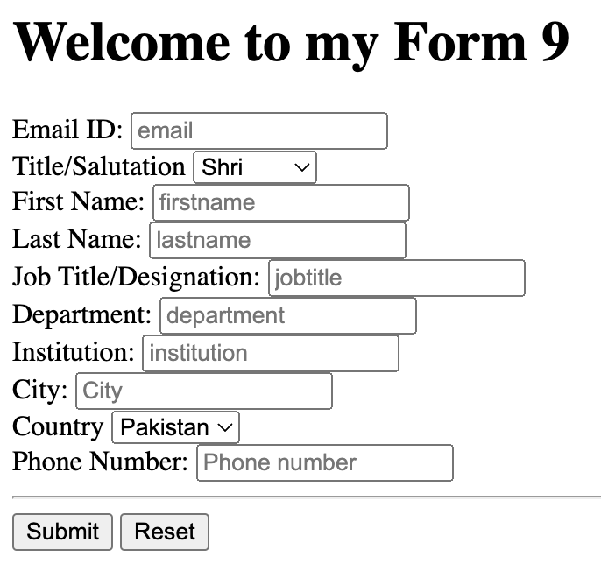

Q10 :

<!DOCTYPE html>

<html lang="en">

<head>

<meta charset="UTF-8">

<meta name="viewport" content="width=device-width, initial-scale=1.0">

<title>Shopping Website</title>

<style>

.img{

height: 1;

width: 1;

}

</style>

</head>

<body>

<header>

<h1>Shopping Website</h1>

</header>

<div>

<img src="images/img1.jpg" alt="Product 1" height="1" width="1">

<h2>Product 1</h2>

<p>Price 129 INR</p>

<p>Items Remaining: 5</p>

</div>

<div>

<img src="images/img2.jpg" alt="Product 2" class="img">

<h2>Product 2</h2>

<p>Price: 140</p>

<p>Items Remaining: 10</p>

</div>

</body>

</html>

OUTPUT:   
